**Meta Description:** BitsCrunch (BCUT) surges 17.6% in a week while experts predict FloppyPepe (FPPE) could deliver even bigger gain

**Keywords:**

BitsCrunch price

BitsCrunch

AI-powered NFT Guardian

NFT

FloppyPepe

FPPE

# **BitsCrunch Price Wild Ride: Why This AI-Powered NFT Guardian Is Up 17.6% In A Week**

The cryptocurrency market has survived on trends and media hype. While the introduction of NFTs sent massive noise globally, its lack of intrinsic value shortened its peak days. However, a new generation of AI-powered NFT guardians are writing a new story. Having begun a Hackathon to improve its network, the BitsCrunch price has increased by 17.6% weekly. Nevertheless, crypto experts say [FloppyPepe (FPPE)](https://floppypepe.io/), another AI meme coin, will outperform this AI-powered NFT guardian with more mouthwatering profits.

## **BitsCrunch Price: Can Incoming Updates Push The AI-powered NFT Guardian To New Levels?**

In a bid to fortify its network, [BitsCrunch (BCUT)](https://www.coingecko.com/en/coins/bitscrunch-token) launched a Hackathon. In a recent [tweet](https://x.com/bitscrunch/status/1891497875366113772?s=46), the AI-powered NFT Guardian showed that their selection process has shortlisted 10 projects. While all the projects aim to improve NFT performance, the BitsCrunch price anticipates a new level. Its recent [acquisition](https://x.com/bitscrunch/status/1897690426074972179?s=46) of Nidum triggered the BitsCrunch price wild ride.

According to an analyst, investors are [bullish](https://x.com/costa_crypto/status/1897592107985977408?s=46) on the BitsCrunch price because of this strategic move. While the BitsCrunch price is rumored to gain 17.6% in a week, the attention is on FloppyPepe (FPPE). Industry experts are certain the AI meme coin will outshine the AI-powered NFT Guardian in 2025.

## **Why Analysts Say FloppyPepe (FPPE) Will Outperform This AI-powered NFT Guardian**

Analysts say FloppyPepe (FPPE) will outshine BitsCrunch’s (BCUT) 17.6% gain in 2025. While doubters thought the AI meme coin was another media hype, [FloppyPepe (FPPE)](https://floppypepe.io/) has silenced them with its private presale round, where it did massive numbers in 24 hours. Despite being inspired by Matt Furie, the AI meme coin has developed from being a mere meme coin to showing the potential of a real-world asset.

At only **$.0000002,** FloppyPepe (FPPE) provides an affordable entry point for all types of investors. Its AI-based technology, passive income, and deflationary burn mechanism show that this AI meme token offers more than menial gains. It rewards faithfulness and promotes sustainability with a passive 3% reward on every transaction. The **deflationary burn mechanism** also encourages scarcity to preserve the token’s value. Hence, these financial efforts are only the tip of the iceberg.

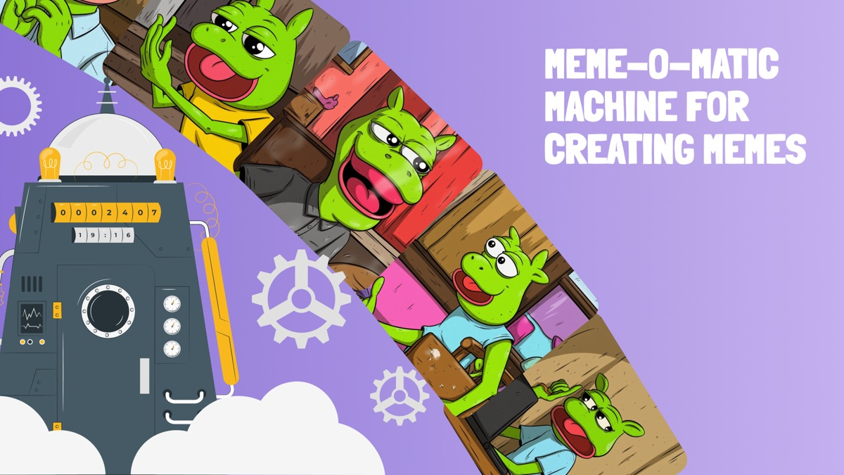

FloppyPepe (FPPE) edges other crypto projects with its multifaceted approaches. Its formidable AI-powered ecosystem allows traders to navigate the volatile market with sophisticated technologies. Its **AI text-to-image** technology, available to Telegram users, helps users earn from digital content. Newbies can transform their **$.0000002** to millions of dollars with the **AI video agent**, while its **AI-powered Meme-o-Matic machine** can monetize viral memes, as seen with NFTs.

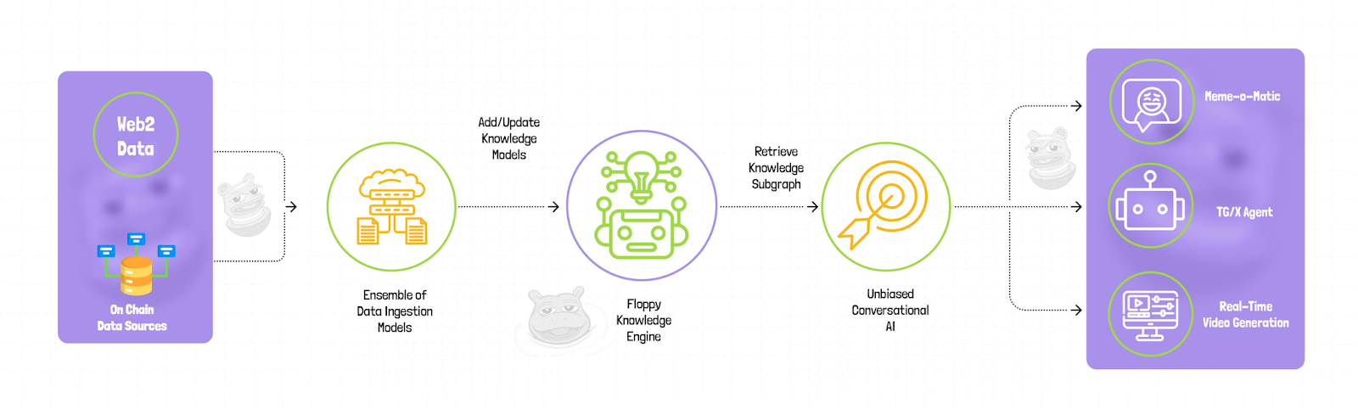

To secure all investments, FloppyPepe (FPPE) completed a [smart audit contract](https://app.solidproof.io/projects/floppypepe) by SolidProof and has created a safe environment for its users. This socially responsible platform allocates a portion of its revenue to **wildlife conservation.** This noble effort is similar to the role of the AI-powered NFT guardian in preserving rare species**.** Hence, FloppyPepe (FPPE) is beyond just creating memes; it is a real-world asset.

A top YouTuber with over 1 million subscribers, NASS Crypto, is one of the many industry experts who have expressed their support for FloppyPepe (FPPE). The $1 million sell-out in its 24-hour private presale round was an initial chance for investors to join. The ongoing presale round is another and the final chance. The tokens are selling out fast.

## **FloppyPepe (FPPE): The Future Of NFTs And Cryptocurrencies**

As the crypto market continues to evolve, AI-powered protocols are reshaping the future of NFTs and digital assets. While the BitsCrunch price has made headlines with its wild ride and strategic acquisitions, analysts believe [FloppyPepe (FPPE)](https://floppypepe.io/) is poised to make an even bigger impact. FloppyPepe (FPPE) is not just another meme coin but a representation of the fusion of AI, blockchain, and real-world asset tokenization.

With its forward-thinking approach and commitment to innovation, FloppyPepe (FPPE) will outsmart the AI-powered NFT Guardian in 2025. As market sentiments shift towards projects with real utility, FloppyPepe (FPPE) stands out as a strong contender for long-term profitability and influence. Its rapid private presale round was only the start. It’s ongoing round is set to break even more records in the coming weeks.

**Join the FloppyPepe (FPPE) presale and community:   
Website:** [**https://floppypepe.io/**](https://floppypepe.io/) **Whitepaper:** [**https://floppypepe.gitbook.io/floppypepe.io**](https://floppypepe.gitbook.io/floppypepe.io) **Telegram:** [**https://t.me/floppypepeofficial**](https://t.me/floppypepeofficial) **X (Twitter):** [**https://x.com/floppypepe**](https://x.com/floppypepe)

